Pacman Test Data:

1.

PLACE 0 0 NORTH

MOVE

MOVE

RIGHT

REPORT

Output: 0, 2, ‘EAST’

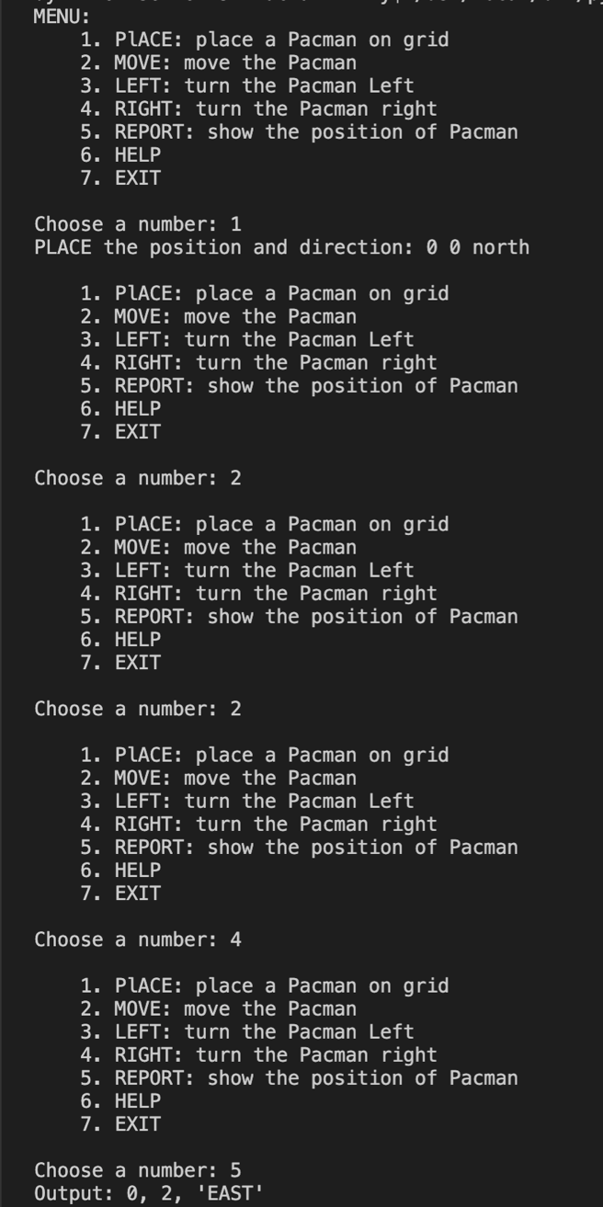

2.

PLACE 1 3 EAST

MOVE

MOVE

RIGHT

MOVE

REPORT

Output: 3, 2, ‘SOUTH’

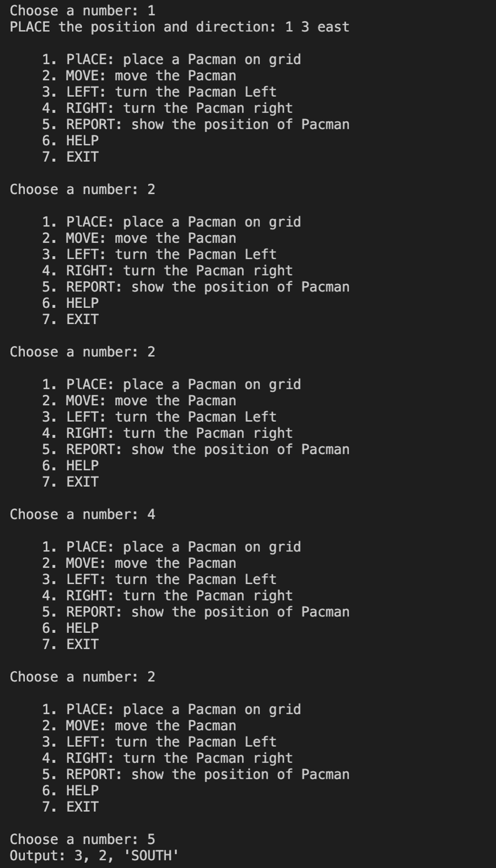

3.

PLACE 2 2 SOUTH

MOVE

MOVE

LEFT

MOVE

REPORT

Output: 3, 0, ‘EAST’

